is hiring for the Spring Season!

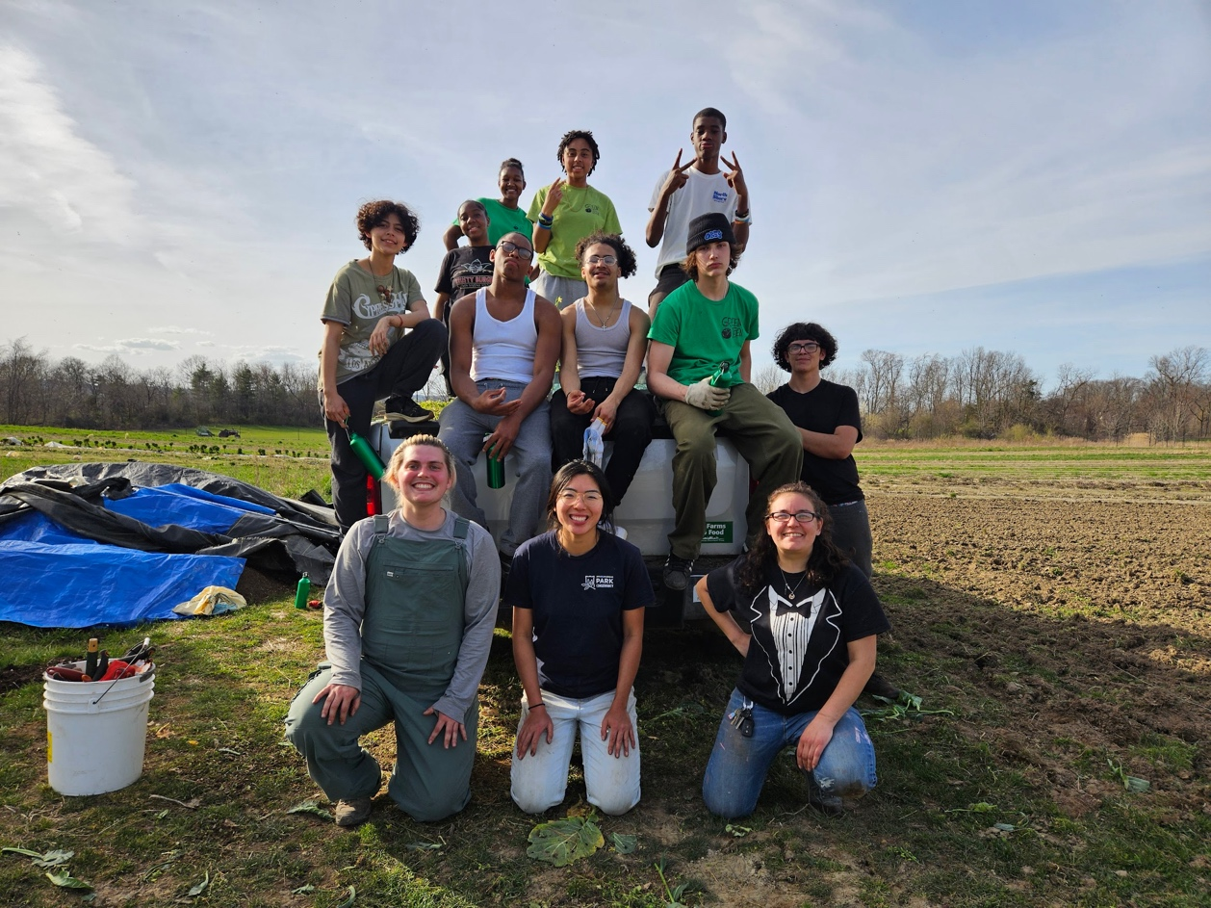

The program provided by this agency is partially funded (funded in part) by NYS OCFS and Dutchess County. Support for this program is also provided through the City of Beacon, Ogden Foundation, Dyson Foundation, and United Way

Green Teen will be accepting applications for our Spring program now through March 5th!

For more information:

Scan the QR Code,

Visit cccedutchess.org,

Visit Green Teen Beacon on Facebook,

Or call Green Teen at 845-831-4287 !